Setting up WSL
- Open the WSL – Ubuntu 22.04.5 LTS and get in folder ardupilot (we can see all the existing folders using cmd – ls) by cmd – cd ardupilot
- Open Windows PowerShell and list out the USB connection using the cmd – usbipd list and connect to the respective USB connection by using the cmd - usbipd attach --wsl --busid 1-4 (<bus id>). For initial setup, run Windows PowerShell as administrator and follow the same.
- We can list the USB connections available in the Linux environment using the cmd - ls /dev/ttyUSB* (for telemetry connections), can open mavproxy by - mavproxy.py --master=/dev/ttyUSB* --baudrate=57600

SITL setup
sim_vehicle.py -v ArduCopter --console --map --out=udp:127.0.0.1:14550

Opening MAVProxy
- Check the available port for the connection by using the cmd - ls /dev/ttyACM*
- Open the MAVProxy - mavproxy.py --master=/dev/ttyACM* --baudrate=115200 --console --map --out=udp:127.0.0.1:14550

HITL Setup for TARLAND

1. Switch to the branch - subash/tarland
2. Make sure the ArduPilot development environment is set up as outlined in building setup for linux
3. Update the following line in the file (ardupilot/Tools/scripts/sitl-on-hardware/extra-hwdef-sitl-on-hw.dat) - define MODE_FOLLOW_ENABLED 1
4. Connect the CubeOrangePlus and build the code using following command
cd ~/ardupilot
./Tools/scripts/sitl-on-hardware/sitl-on-hw.py --board CubeOrangePlus-SimOnHardWare --vehicle copter --simclass MultiCopter --frame X --upload
5. Find the device id by running the following command - ls /dev/serial/by-id/
It will list the device id as follows
usb-CubePilot_CubeOrange+_350050000151333232393436-if00
usb-CubePilot_CubeOrange+_350050000151333232393436-if025.

6. Once the build is complete, connect to MAVProxy with the following command
mavproxy.py --master=/dev/serial/by-id/usb-CubePilot_CubeOrange+_350050000151333232393436-if00 --out=udp:127.0.0.1:14550 --out=udp:127.0.0.1:14551 --map --console
7. Load the mav_tarland.parm file to the board using mavproxy or using GCS
param load <path to mav_tarland.parm file>
param save
param load /mnt/c/IITM/HITL/mav_tarland.parm

Setting up the Build Environment
- Git command line
Linux/Ubuntu users can install with apt:
- sudo apt-get update
- sudo apt-get install git
- sudo apt-get install gitk git-gui

- Clone the ArduPilot repository
https://github.com/ArduPilot/ardupilot.git for the main ardupilot repo
https://github.com/your-github-account/ardupilot for your fork of the ardupilot repo
- open a terminal and navigate to the directory where you would like the clone to be stored
- clone your fork:
git clone --recurse-submodules https://github.com/your-github-userid/ardupilot

cd ardupilot

- Install some required packages

- From the cloned ardupilot directory:
Tools/environment_install/install-prereqs-ubuntu.sh -y

- Reload the path (log out and log in to make it permanent):
. ~/.profile

- Build the code for an autopilot

./waf configure --board CubeOrangePlus
./waf copter
./waf --upload

- Peripheral board

./waf configure --board CubeOrangePlus-SimOnHardWare
./waf copter
./waf --upload

- Use cmd - ./waf clean to clean the previous build

Assembling the Drone for Flight test

- Had a problem with the connectors between Molex Picoblade (components) and JST-GH (CubeOrangePlus)
- Had JST-GH pin telemetry, Buzzer and Power module
- We soldered the GPS wire and JST-GH cable with respective cables, initially connected in the 6-pin port (GPS2_Port). To work in GPS2_Port, we need to disable the SERIAL3_PROTOCOL must be other than 5

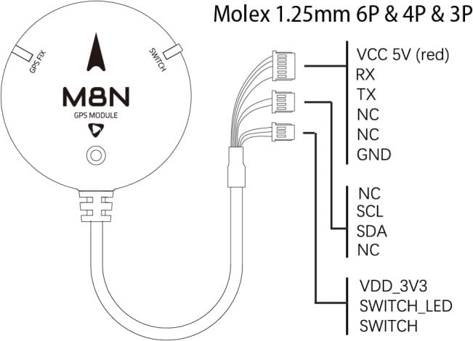
GPS2 port
Pin | Signal | Volt
1 (red) | VCC | +5V
2 (blk) | TX (OUT) | +3.3V
3 (blk) | RX (IN) | +3.3V
4 (blk) | SCL I2C1 | +3.3V
5 (blk) | SDA I2C1 | +3.3V
6 (blk) | GND | GND

- As we need to include the safety switch, we moved to GPS1_Port
GPS1 port
GPS1_Port
1. VCC GPS VCC & Safety switch VCC (Red)
2. TX (out) GPS RX (in) Yellow
3. RX (in) GPS TX (out) Green
4. SCL I2C2 GPS SCL I2C2 (Orange)
5. SDA I2C2 GPS SDA I2C2 (White)
6. Button Safety switch – safety (Yellow)
7. Button LED Safety switch – LED (Black)
8. GND GPS GND (Black)
Pin | Signal | Volt
1 (red) | VCC | +5V
2 (blk) | TX (OUT) | +3.3V
3 (blk) | RX (IN) | +3.3V
4 (blk) | SCL I2C2 | +3.3V
5 (blk) | SDA I2C2 | +3.3V
6 (blk) | Button | GND
7 (blk) | button LED | GND
8 (blk) | GND | GND
Adding a New Flight Mode to Copter

- Refer is link - https://ardupilot.org/dev/docs/apmcopter-adding-a-new-flight-mode.html

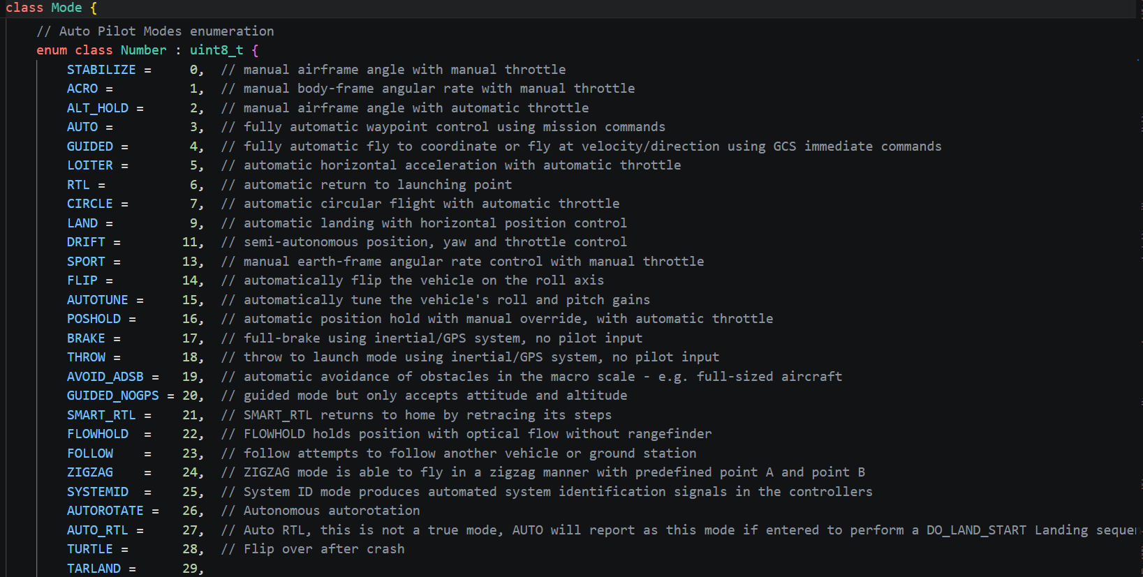
- Pick a name for the new mode and add it to the bottom of the control_mode_t enum in mode.h just like “TARLAND” has been added below.

- Define a new class for the mode in mode.h. It is probably easiest to copy a similar existing mode’s class definition and just change the class name (i.e. copy and rename “class ModeStabilize” to “class TARLAND”). The new class should inherit from the Mode class and implement run(), name() and name4() and optionally init().

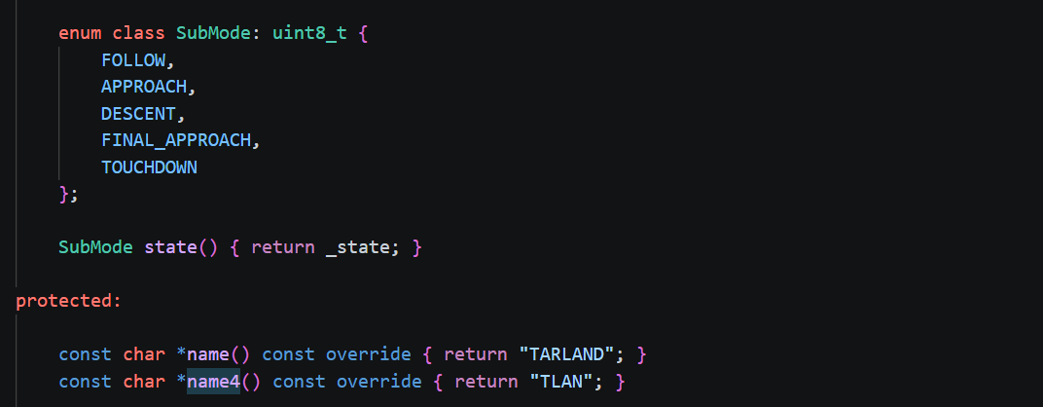
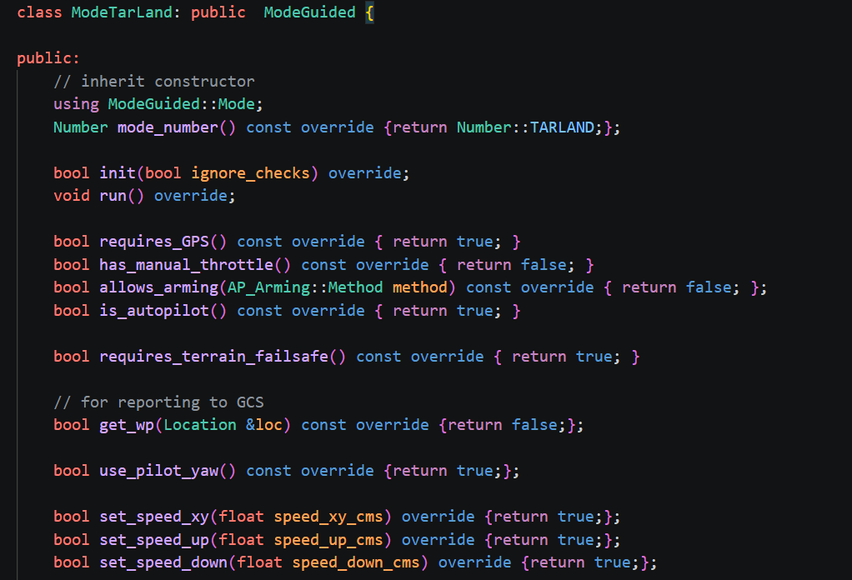

- Create a new mode_tarland.cpp file based on a similar mode, such as mode_stabilize.cpp or mode_loiter.cpp.

- Instantiate the new mode class in Copter.h by searching for “ModeAcro” and then adding the new mode somewhere below.
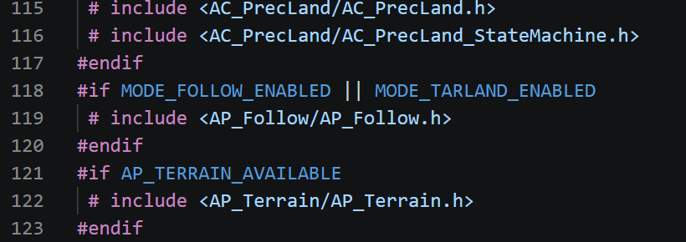

- In mode.cpp add the new mode to the mode_from_mode_num() function to create the mapping between the mode’s number and the instance of the class.
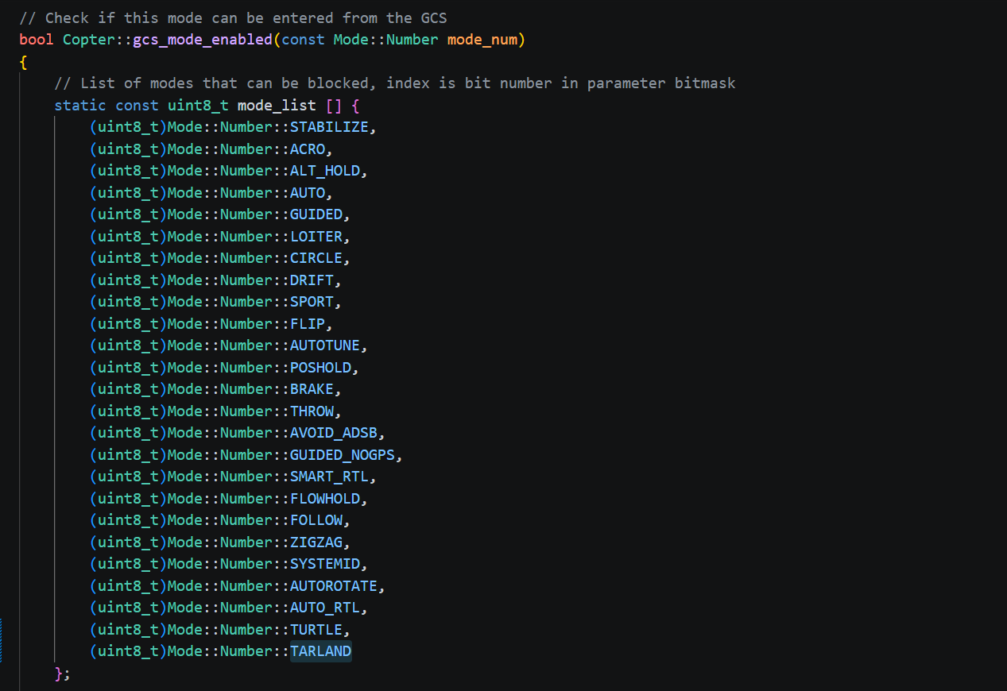
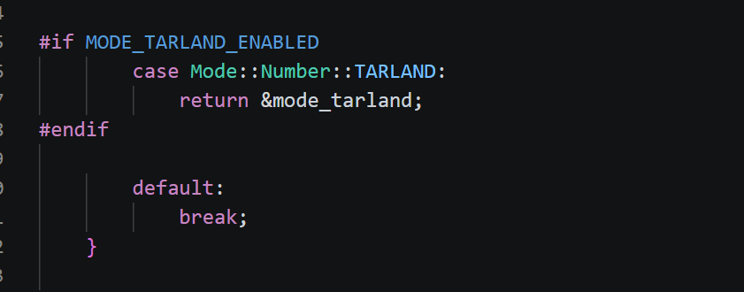

- Add the new flight mode to the list of valid @Values for the FLTMODE1 ~ FLTMODE6 parameters in Parameters.cpp (Search for “FLTMODE1”).
// @Param: FLTMODE1
// @DisplayName: Flight Mode 1
// @Description: Flight mode when pwm of Flightmode channel(FLTMODE_CH) is <= 1230
// @Values: 0:Stabilize,1:Acro,2:AltHold,3:Auto,4:Guided,5:Loiter,6:RTL,7:Circle,9:Land,11:Drift,13:Sport,14:Flip,15:AutoTune,16:PosHold,17:Brake,18:Throw,19:Avoid_ADSB,20:Guided_NoGPS,21:Smart_RTL,22:FlowHold,23:Follow,24:ZigZag,25:SystemID,26:Heli_Autorotate,27:Auto RTL,28:Turtle,29:Tarland
// @User: Standard
GSCALAR(flight_mode1, "FLTMODE1", (uint8_t)FLIGHT_MODE_1),

- Optionally you may wish to add the flight mode to the COPTER_MODE enum within the mavlink/ardupilotmega.xml because some ground stations may use this to automatically populate the list of available flight modes.
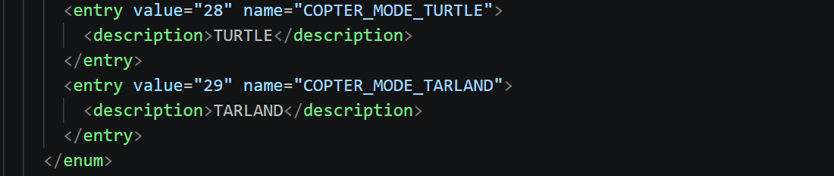

Creating Custom mode in GCS
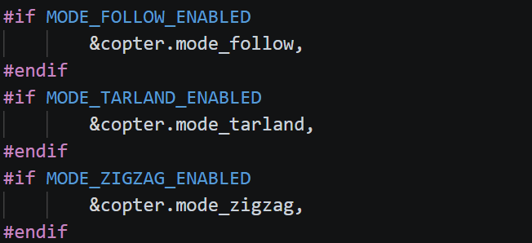
- Add TARLAND to send_available_mode()

- MAVProxy - Add TARLAND to mode_mapping_acm{} –modules/mavlink/pymavlink/mavutil.py and then run python setup.py build install --user
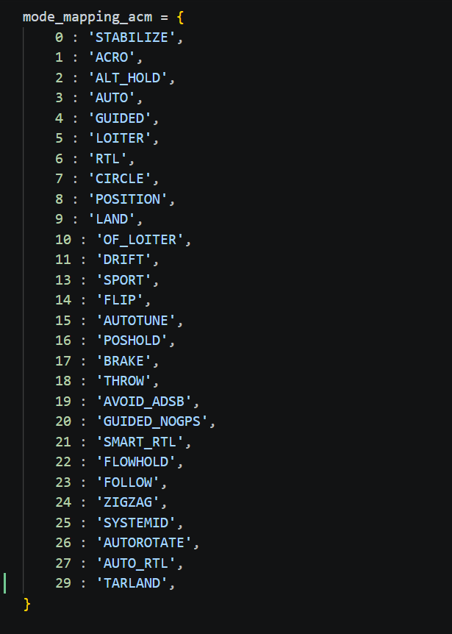

- MissionPlanner – Exact the ArduCopter.apm.pdef.xml.gz file 7 – Zip Exact here open ArduCopter.apm.pdef.xml file and add TARLAND to Flight Mode * (1 – 6) and Initial Mode as well.

  - Refer - https://discuss.ardupilot.org/t/new-flight-mode-not-shown-in-mission-planner/42193/17?utm_source=chatgpt.com
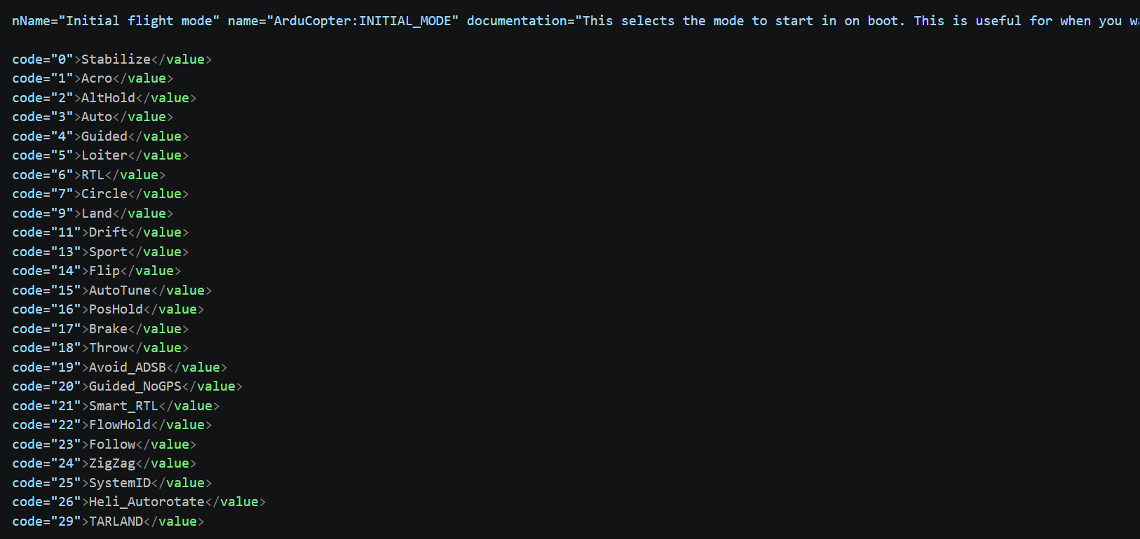
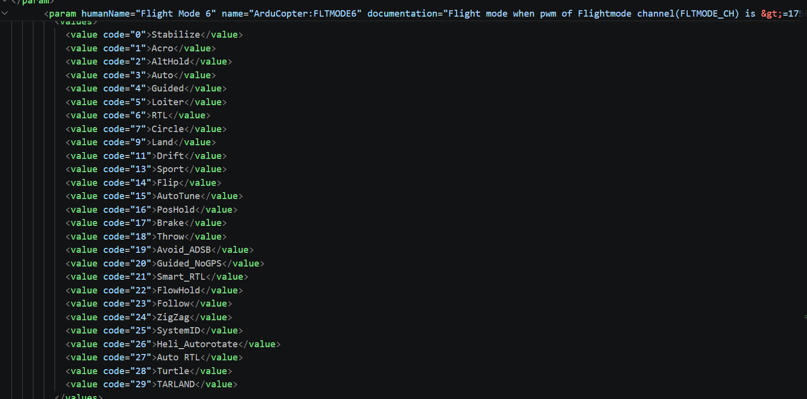

Follow Offset

- Ap_follow.h

Added - Vector3f get_offset() const;

- Ap_follow.cpp

Added -
Vector3f AP_Follow::get_offset() const
{
return _offset_m.get();
}

- Mode_TARLAND.cpp
float dist_xy = dist_vec_offs.xy().length();
if(dist_xy > MIN_FOLLOW_DIST){
Vector3f offset = g2.follow.get_offset();
offset.z = -HOVER_ALT;
g2.follow.set_offset(offset, offset_type);
follow_target();
}else if(dist_xy <= MIN_FOLLOW_DIST) {
if(dist_vec.z > MIN_DESCENT_ALT_OFF) {
Vector3f offset = g2.follow.get_offset();
offset.z = -MIN_DESCENT_ALT_OFF;
g2.follow.set_offset(offset, offset_type);
follow_target();
} else if(dist_vec.z <= MIN_DESCENT_ALT_OFF) {
perform_landing();
}
}
}

